732_Saksham Shetkar

Big Data Technology

**Practical : 4**

Aim : Matrix Multiplication using MapReduce.

Step 1 : Open terminal.

Create two text files of matrix m1.txt and m2.txt.

[cloudera@quickstart ~]$ cd ~/Desktop

[cloudera@quickstart Desktop]$ mkdir matrix_mul

[cloudera@quickstart Desktop]$ cd matrix_mul

[cloudera@quickstart matrix_mul]$ gedit m1.txt

m1

1 2 3

4 5 6

[cloudera@quickstart matrix_mul]$ gedit m2.txt

m2

7 8

9 10

11 12

Step 2 : Create Mapper file mapper.py

[cloudera@quickstart matrix_mul]$ gedit mapper.py

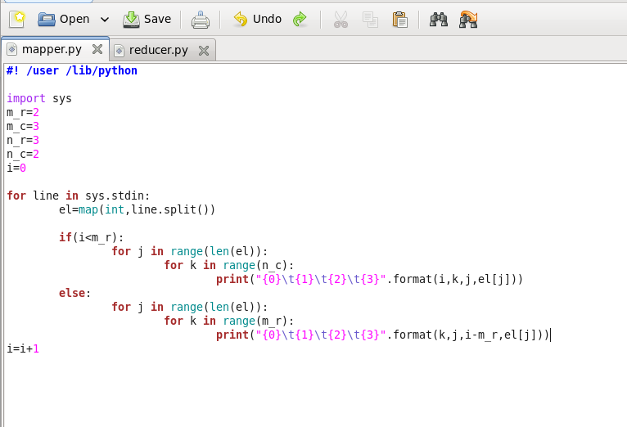

[cloudera@quickstart matrix_mul]$ cat m1.txt m2.txt | python mapper.py

Mapper Output :

0 0 0 1

0 1 0 1

0 0 1 2

0 1 1 2

0 0 2 3

0 1 2 3

0 0 0 4

0 1 0 4

0 0 1 5

0 1 1 5

0 0 2 6

0 1 2 6

0 0 0 7

0 1 0 7

0 0 1 8

0 1 1 8

0 0 0 9

0 1 0 9

0 0 1 10

0 1 1 10

0 0 0 11

0 1 0 11

0 0 1 12

0 1 1 12

Step 3 : Create Reducer file reducer.py

[cloudera@quickstart matrix_mul]$ gedit reducer.py

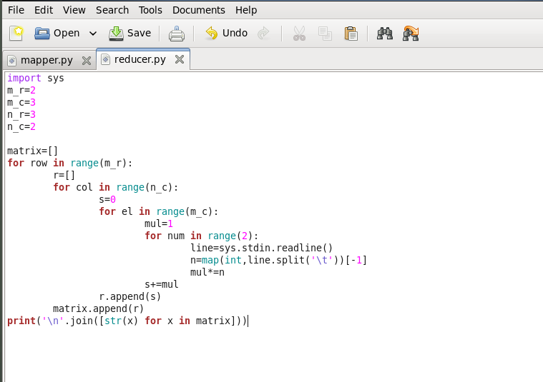

Step 4 : to get matrix multiplication :

[cloudera@quickstart matrix_mul]$ cat m1.txt m2.txt | python mapper.py | python reducer.py

**Output :**

[14, 77]

[194, 365]